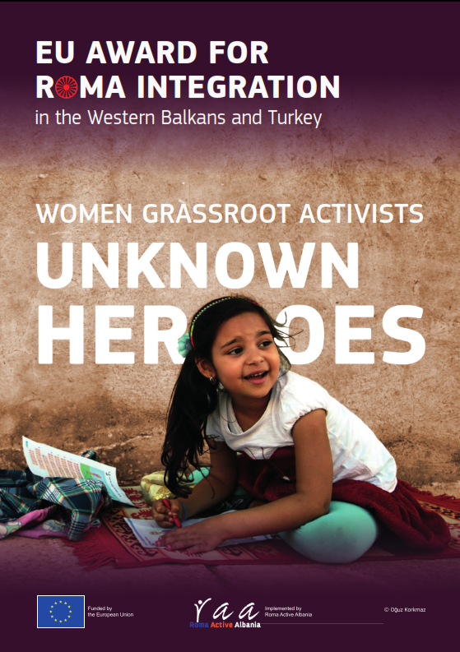

Rules of contest and award criteria.

EU Award for Roma Integration in the Western Balkans and Turkey, 2019- “Unknown Heroes”

- Background
With an estimation of 12 million living in Europe, the Roma minority is one of the largest ethnic minorities in Europe. About 1 million Roma live in the Western Balkans and 2.8 million in Turkey, sharing a rich culture and history that is inextricably linked to Europe, but have also faced a long history of exclusion. Yet today many Roma still face severe forms of racism, discrimination, social exclusion and poverty, thus improving their situation continues to be a key priority for the European Commission.

Moreover, the Roma women face a double discrimination, being discriminated by being Roma and then by being women.. Roma women in the Western Balkans and Turkey face exclusion from policy-making, difficulties to access education and employment, absence of qualitative health care and domestic violence. Despite this, Roma women are key factors behind their families andRoma integration, being aware of the difficulties that the Roma population suffers and in many occasions pushing theircommunities toward self-organization and advocacy actions.

The EU is pushing to improve the social integration of Roma into society and to provide tangible results on the ground. The European Union is also providing substantial funds for social integration measures through the Instrument for Pre-accession Assistance.

The Enlargement countries have adopted strategic action plans, on Roma integration. Important work is done through national and local CSOs and individuals/activists, whose work is providing the first support to the Roma communities.
Most of the efforts focus on measures to increase access to education and to decrease drop-out rates, to foster employment opportunities, and to improve health and housing conditions, particularly by ensuring access to public services, civil documentation and registration.

These efforts are implemented at grassroots level often carried out individually by members of Roma communities, often women who despite their successes still are unknown to the public.

Honouring these efforts, since 2014, the DG NEAR Award on Roma Integration is raising the visibility of existing challenges faced by Roma in the enlargement countries, the important work of CSOs and activists in support of Roma integration, that is a key enlargement priority as part of the area on fundamental rights.

The EU Award on Roma Integration 2019 is dedicated to Roma women who brought significant changes to their communities, and alternatively to key Roma women in civil society organisations.

The award is funded European Union (IPA Funds) and implemented by Roma Active Albania(RAA).

- Aim of the award

The EU award on Roma integration is a direct encouragement of the work done by Roma grassroots women, in the Western Balkans and Turkey, who are the “Unknown Heroes” of theircommunities,being the key actors to improve the social integration of Roma.

It is a direct unconditional support for the grassroots Roma women, alternatively Roma women engaged in civil society organisations, living in Albania, Bosnia and Herzegovina, Montenegro, Serbia, the former Yugoslav Republic of Macedonia, Kosovo* and Turkey; to recognise their achievements and to further continue their efforts in bringing more significant changes in the living conditions and integration of Roma communities.

The award specifically aims to:
- Reinforce and highlight the role and contribution of Roma women to the Roma integration process.
- Promote Roma women role models who have brought positive changes to their communities.
- Make visible the support and work of the European Union for the Roma integration
- Foster the cohesion among the actors involved in the process of Roma integration and empower Roma women within their communities.
- Ensure recognition and sustainability of actions implemented at grassroots level.
- Identify and share positive examples of work of CSOs and especially Roma women activists at local level.

An independent evaluation panel will review the applications and select the winners of the award.

Two prizes will be granted for each of the seven (7) countries, with a value of 7.500 Euro as first prizes and 4.500 Euro as second prizes, to a total of fourteen winners. It is expected that the Roma women winners will use the prize to follow-up on their Roma integration activities.
The award winners will be invited to attend a 3-day study visit to the European Institutions in Brussels, Belgium, on the occasion of the Roma Week 18-21 March2019.

- Rules of contest

The award is open to individuals who are; Roma grassroots women, and alternatively, Roma women in CSOs; resident in Albania, Bosnia and Herzegovina, Montenegro, Serbia, the former Yugoslav Republic of Macedonia, Kosovo and Turkey.
The contest is open to applications directly from the individuals, and nominations from a relevant group of individuals, international organisations, CSOs and public authorities, established/active in one of the enlargement countries.

Applications
- Applications can be directly submitted by interested individuals.
- Applications must be in the respective form, readable, accessible and printable.
- Incomplete applications may be considered inadmissible if essential elements are missing.
- An application is considered valid, when is duly filled-in together with the Declaration of Honour.
- Applications must be submitted together with the relevant documentation, such as photographs, short video clips (max. 5min), or similar.
- Only one application can be submitted. In case of multiple applications, the applicant will be disqualified.

Nominations
- Nominations can be submitted by private individuals, a relevant group of individuals, international organisations,civil society organisations and public authorities, established or active in the enlargement region:Albania, Bosnia and Herzegovina, Montenegro, Serbia, the former Yugoslav Republic of Macedonia, Kosovo and Turkey; with the consent of the nominee.
- Nominations must be in the respective form, readable, accessible and printable.
- Incomplete applications may be considered inadmissible if essential elements are missing.
- A nomination is considered valid, when is duly filled-in together with the Declaration of Honour.
- Nominations must be submitted together with the relevant documentation, such as photographs, short video clips (max. 5min), or similar.
- Only one nomination can be submitted by each private individual/CSO/international organisation/public authority. In the case of international organisations they can only submit one nomination per country. In case of multiple nominations by the person/CSOs/IO/public authorities, theywill be disqualified.

Supporting documents
Applicantsand nominators, are invited to provide additional supporting information as available, and encouraged to send documents in electronic version whenever possible. Supporting information may include:
  - Video clips, photographs;
  - publications (leaflets, brochures etc. promoting the initiative/project);
  - links to websites related to the initiative/project (to be mentioned in the application form)
  - media coverage (if any);
  - any other material and proof of the impact of the initiative implemented by the applicant/nominee for the prize

Multiple submissions
Only one application can be submitted by each individual.
Each person/CSO/IO and/or public authorities can nominate only one person.
Multiple applications and nominations will result in disqualification.
An individual, who is applying as applicant, cannot be nominated, and as well, a nominee cannot directly apply for the award.

Consent on use of information for publication.
Some information provided from the applicants, nominators and nominees, can be used for further publications. Thus a consent form signed by all parties shall be submitted together with the other documents.

Language
The language used for both applications and nominations, is English.
The supporting documents can be in different languages, however English versions will be appreciated.

Deadlines
Deadline for submitting the applications and nominations, together with other relevant documentations, is 15 February 2019, 23:59 Brussels Time.

Submission
Submission of applications shall be via e-mail in the address: Application_EU_Award_2019@raa.al.
The title of the email must contain the initials of the applicant and the country of origin.

Submission of nominations shall be via email in the address: Nomination_EU_Award_2019@raa.al.
The title of the email must contain the acronym of the nominator, initials of the nominee and the country of origin.

Applications and nominations, along with the supporting documents, can also be sent by post at the address:
Roma Active Albania - Rr. “YlbereBylykbashi”; P. 25; Shk. 2; Ap. 4; Tirana, Albania
In this case, onlythe applications/nominations received by us within the deadline will be considered. Applications reaching by post later than the set deadline, shall not be considered for evaluation.

- Eligibility criteria
The award welcomes applications and nominations from Albania, Bosnia and Herzegovina, Montenegro, Serbia, the former Yugoslav Republic of Macedonia, Turkey or Kosovo.

- Candidates
The candidates must be individual Roma grassroots women, alternatively Roma women working in CSOs, fulfilling the following criteria and committing to use the monetary award included in this prize to pursue actions in support of the Roma integration.

Individuals Roma grassroots women, specifically:
- residents in one of the countries; Albania, Bosnia and Herzegovina, Montenegro, Serbia, the former Yugoslav Republic of Macedonia, Kosovo and Turkey;
- active in grassroots community, promoting the activities mentioned under ‘b” at the local level for a minimum of 2 years.

Alternatively, Roma Women in CSOs, specifically:
- CSOs from Albania, Bosnia and Herzegovina, Montenegro, Serbia, the former Yugoslav Republic of Macedonia, Kosovo and Turkey;
- CSOs having implementing projects as stated under ‘b’ at the local level for a minimum of 2 years;
- CSOs able to prove that the initiative for which the application/nomination is made has been carried out for a minimum of 6 months prior to applying/being nominated for the award. The project implementation cannot have been completed before 1 July 2018;

- The types of activities eligible for the award
The prize will be an unconditional support for grassroots Roma women activists, alternatively Roma women in CSOs, to continue their work promoting significant changes to the living conditions and integration of Roma, in the field of:

- Human Rights,
- Education,
- Housing,
- Healthcare,
- Gender equality/empowerment,
- Antidiscrimination
- Fighting antigypsyism
- Employment
- Civil documentation

- Award criteria

The winners of the Award for Roma Inclusion will be selected by an independent panel of evaluators, according to the following award criteria whereby transparency of the procedure and equal treatment of the participants will be ensured:

The main awarding criteria will include, but not be limited to:

- Direct impact / concrete change on the local Roma community or individual Roma persons (Where the activity is still ongoing, results must have already led to impact), in one of the following fields:
  - Human Rights,
  - Education,
  - Housing,
  - Healthcare,
  - Gender equality/empowerment,
  - Antidiscrimination
  - Fighting antigypsyism
  - Employment
  - Civil documentation

- Use of innovative and creative elements and/or sector specific methodologies; (such as alternative education, participatory approach etc.)

- Appropriateness and coherence of activities carried out with the regard to the characteristics and needs of their target groups;

- The work and role played by the grassroots Roma women/Roma women in CSOs has improved the relations between Roma and non-Roma community and involve local authorities;

- Sustainability of the initiative, including whether the activity and role of the awardee has inspired other women in the community and/or led to further a community driven initiatives.

- If support and funding for the actual work implemented, is obtained by a donor, the participant will need to demonstrate ownership of an innovative approach and/or the method of work.

- Use of Data

Submitted data and personal information will be treated confidentially, solely for the purpose of the award.

All personal data contained in the application shall be processed in accordance with regulation (EU) 2018/1725 of the European Parliament and of the Council of 23 October 2018 (OJ L 295, 21.11.2018, p. 39–98 )) on the protection of individuals with regard to the processing of personal data by the Community institutions and bodies and on the free movement of such data. Such data shall be processed by the Contracting Authority solely in connection with the implementation and follow-up of the application of the winner, without prejudice to a possible transmission to the bodies in charge of a monitoring or inspection task in accordance with European Community and European Union legislation.

Participants may, at any time, lodge a complaint against the processing of their personal data with the European Data Protection Supervisor.
The Commission shall only be authorized to publish, in whatever form and on or by whatever medium, the following information:

- The name of the winning applicant or nominee
- The name of the nominator
- The general purpose of the activities of the winning to the award of the prize;
- The amount of the prize awarded;
- The geographic location of the activities carried out.

The European Commission may produce videos or other promotional material about the winners. Photos and videos taken by the European Commission either in preparation of the award ceremony or during the award ceremony are the sole property of the European Commission.

As it is most commonly used in EU policy documents and discussions, the term "Roma" refers to a variety of groups of people who describe themselves as Roma, Gypsies, Travellers, Manouches, Ashkali, Egyptian, Sinti and other without denying the specificities of these groups.
* This designation is without prejudice to positions on status, and is in line with UNSCR 1244/1999 and the ICJ Opinion on the Kosovo declaration of independence.

